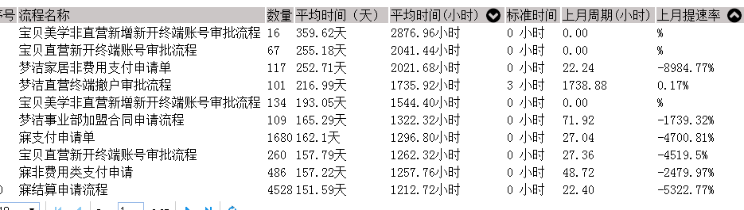

Proc instal 里面的流程名字与流程id

流程id 貌似不是

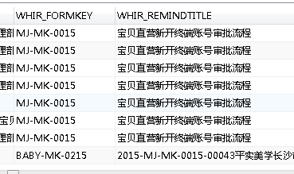

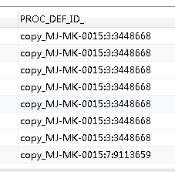

是一样的。。

"毫秒到天" ( AI."DURATION_") as 持续时间天,

"角色分析_延误数量" ("流程ID", role_id) AS 延误数量,

AND IS_DEPLOYED = 1

f.PROCESSID IS NOT NULL